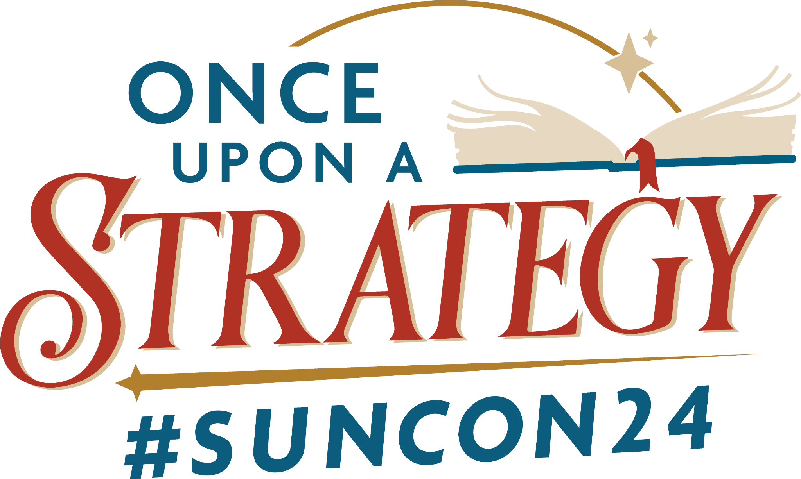

Dear [*supervisor’s name*],

I am reaching out to discuss my professional development, specifically an interest in attending the [Public Relations Society of America (PRSA) Sunshine District Conference](https://prsasunshine.org/district-conferences/) #SunCon24 being held in Orlando at *Disney’s BoardWalk* Inn on July 25 and 26.

Attending this conference will give me exposure to more than 200 public relations, communications, and marketing professionals from throughout Florida and beyond, and ensure that we’re knowledgeable on the latest best practices.

The conference theme, *Once Upon a Strategy*, focuses on the importance of strategic storytelling in developing and implementing effective public relations campaigns. It will feature national and regional speakers, including sessions hosted by the Disney Institute and the Walt Disney World Public Affairs Team. Sessions will deep dive into critical and timely components of public relations, including leadership, employee engagement, the role of AI, crisis communication, strategic planning, impactful storytelling, the power of influencing, and so much more. The full agenda, featuring four keynote sessions and 13 main breakout topics to choose from, [is linked here](https://prsasunshine.org/district-conferences/agenda/).

The conference is scheduled to begin Thursday, July 25 at 1:30 p.m. and ends Friday, July 26 at 3 p.m.

The cost for [conference registration](https://www.eventbrite.com/e/prsa-sunshine-district-conference-suncon24-tickets-866995606197) is [*(through June 7) Early Bird Pricing PRSA Members: $249; Non-Members: $349; Students: $50 | Regular Pricing (June 8-July 15) PRSA Members: $299; Non-Members: $399; Students: $50*], plus Eventbrite processing fees. SELECT THE TIME PERIOD THAT APPLIES TO YOU

I expect to come back with plenty of actionable, practical takeaways, new strategies and improved skills.

Thank you for your consideration. I look forward to hearing from you soon!

[*Your name*]  
  
If employer is unfamiliar with PRSA or PRSA Sunshine District, add:  
  
About PRSA  
The Public Relations Society of America (PRSA) is the largest public relations organization in the world with more than 21,000 members, including 1,000 in Florida’s Sunshine District. Chartered in 1947, PRSA is the foremost organization of public relations and communications professionals. PRSA provides professional development, sets standards of excellence, and upholds principles of ethics for its members and, more broadly, the multi-billion-dollar global public relations profession.  
  
About PRSA Sunshine District  
Public Relations Society of America (PRSA) Sunshine District represents 1,000 public relations and communications professionals from seven chapters throughout Florida. It provides educational resources, scholarships, and professional development opportunities for the industry’s leading professionals. Its members represent many industries and facets of public relations, including corporate communications, technology, public affairs, financial communications, healthcare, nonprofit, education, travel and tourism, government, technology and international public relations.